Advances in Traditional Medicine

https://doi.org/10.1007/s13596-020-00475-1

**RESEARCH ARTICLE**



**,**

**Noor Muhammad1** **· Nisar Uddin2 · Muhammad Khalil Ullah Khan1 · Muhammad Umer4 · Niaz Ali2 · Shariat Ullah3**

Received: 6 April 2020 / Accepted: 18 June 2020

© Institute of Korean Medicine, Kyung Hee University 2020

**Abstract**

*Aesculus indicaAjuga bracteosa*

*A. indica A. bracteosa Ajuga niponsisAllium cepa*

*Aesculus indica* *A. bracteosa.*

*A. indicaAnesthetics*

**Introduction**

**\***

1 3



\ N. Muhammad et al.

**Materials and methods**

**Study site**

**Statistical analysis**

UVI = ΣUI



NI

**R**

RFCS = FC



N

1 3

T,…

**.**

**CCI**

CI= N ×100

N

FL (%) = *IP* × 100

*IU*

*Ip*

*Iu*

**I**

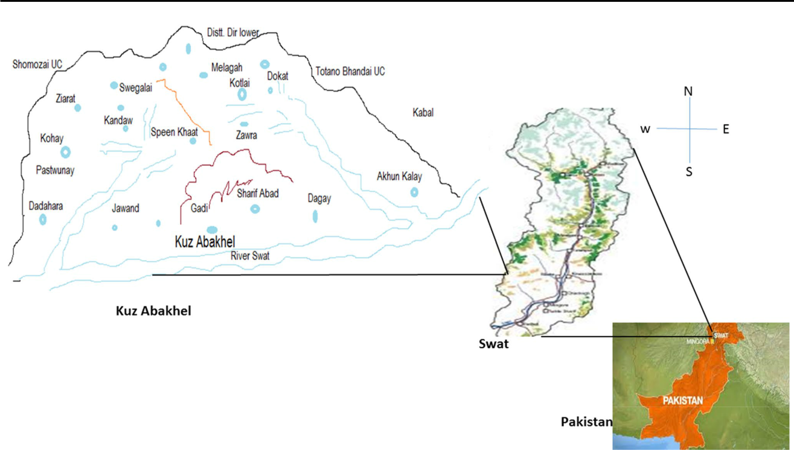

NUR − NT

FIC =



NUR−1

**Results and discussion**

**Demographic features**

1 3

|  |  |  |
| --- | --- | --- |
| \ |  | N. Muhammad et al. |
|  | |  |
| *bracteosaAjuga niponsisAllium cepa* | |  |
|  | *Allium sativumAloe vera* |  |
|  | *Amaranthus spinosus* | *, Amarnthus viridis* |
|  | *Arthimesa dubiaArtimisa scoporia* | |
| *Asparagus gliciusAvena sativaBarber* | | *-* |
| *ries lyciumCalotropis proceraCapsicum* | | |
| *annumCarthamus oxycanthaCarum* | |  |
| *carvi* | *Cedrela serrata* | *Cedrus deo-* |

*daraCenabis sativaChenopodium ambro-*

*sioidesChenopodum albumCichorium*

*intybus*

*Aesculus indica*

*Ajuga bracteosa*

*Ajuga niponsisAllium cepaAllium sati-*

*vumAloe veraAmaran-*

*thus spinosusAmarnthus viridisArthimesa*

*dubiaArtimisa scoporiaAsparagus glicius*

*Avena sativa* *Barberries lycium* *Ziziphus sativa*

*Calotropis proceraCapsicum annum*

*Carthamus oxycanthaCarum carviCedrela*

*serrataCedrus deodaraCenabis*

*sativa* *Chenopodium ambrosioides* *Che-*

*nopodum albumCichorium intybus* *Con* *-*

*volvulus orevensisCuminum cyniumCyn-*

*odan dictylan* *Daphne mucronata*

*Delpphinium unciaatumDesmostachya bipinnata*

’

’

**R**

*Aes* *-*

*culus indica* *Ajuga*

1 3

T,…

*Aesculus indica*

*Ajuga bracteosa*

*Ajuga niponsis*

*Allium cepa*

*Allium sativum*

*Aloe vera*

*Amaranthus spinosus*

*Amarnthus viridis*

*Arthimesa dubia*

*Artimisa scoporia*

*Asparagus glicius*

*Avena sativa*

*Barberries lycium*

*Calotropis procera*

*Capsicum annum*

*Carthamus oxycantha*

*Carum carvi*

*Cedrela serrata*

*Cedrus deodara*

*Cenabis sativa*

1 3

\ N. Muhammad et al.

*Chenopodium ambro-*

*sioides*

*Chenopodum album*

*Cichorium intybus*

*Convolvulus orevensis*

*Cuminum cynium*

f

*Cynodan dictylan*

*Daphne mucronata Royle*

*Delpphinium unciaatum*

*Desmostachya bipinnata*

*Duehesnesa indicia*

*Euphorbia heliscopa*

*Ficus carica*

*Foeniculum vulgare*

*Fumaria indica*

*Hyoscyamus niger* f *Jasminum humile*

*Justscia adhotoda*

*Mallotus philippensis*

*Malva neglecta*

*Melia azedarach*

*Mentha arvensis*

*Mentha longifolia*

1 3

T,…

*Micromeria biflora*

*Mirabilis jalapa*

*Myrisina ofricna*

*Narcissus tazetta*

*Nastartium ofcinale*

*Ocimum basilcum*

*Olea ferruginea*

*Oxalis corniculata*

*Paeonia emodi*

*Plantago lanceolata*

*Plectranthus rogosus*

*Porulaca olaraceae*

*Primula denticulata*

*Pronus armeniaca*

*Punica granatum*

*Quercus dilatata*

*Ricinus communis*

*Rumex dentatus*

*Saliva moorocroftiana*

1 3

\ N. Muhammad et al.

*Solinum nigrum*

*Sonchus asper*

*Sonchus oleraceus*

*Sorgham halense*

*Spinaceae oleraceae*

*Tamarix aphyla*

*Teucrium stocksianum*

*Tribulus terrestris*

*Verbascum Thapsus*

*Verbena ofcinalis*

*Zanthoxylum armatum*

*Ziziphus oxiphylla*

*Ziziphus sativa*

*Aesculus indica*

*Ajuga bracteosaAjuga niponsis*

*Allium cepaAllium sativumAloe vera*

*Amaranthus spinosus*

*Amarnthus viridisArthimesia dubia*

*Artimisa scoporiaAsparagus glicius*

*Avena sativaAvena sativaBarberries*

*lyceumCalotropis proceraCapsicum*

*annumCarthamus oxycanthaCarum*

*carviCedrela serrataCedrus* *Ziziphus oxiphylla*

*deodaraCenabis sativaChenopodium* *Ziziphus sativa*

*ambrosioides*

1 3

T,…

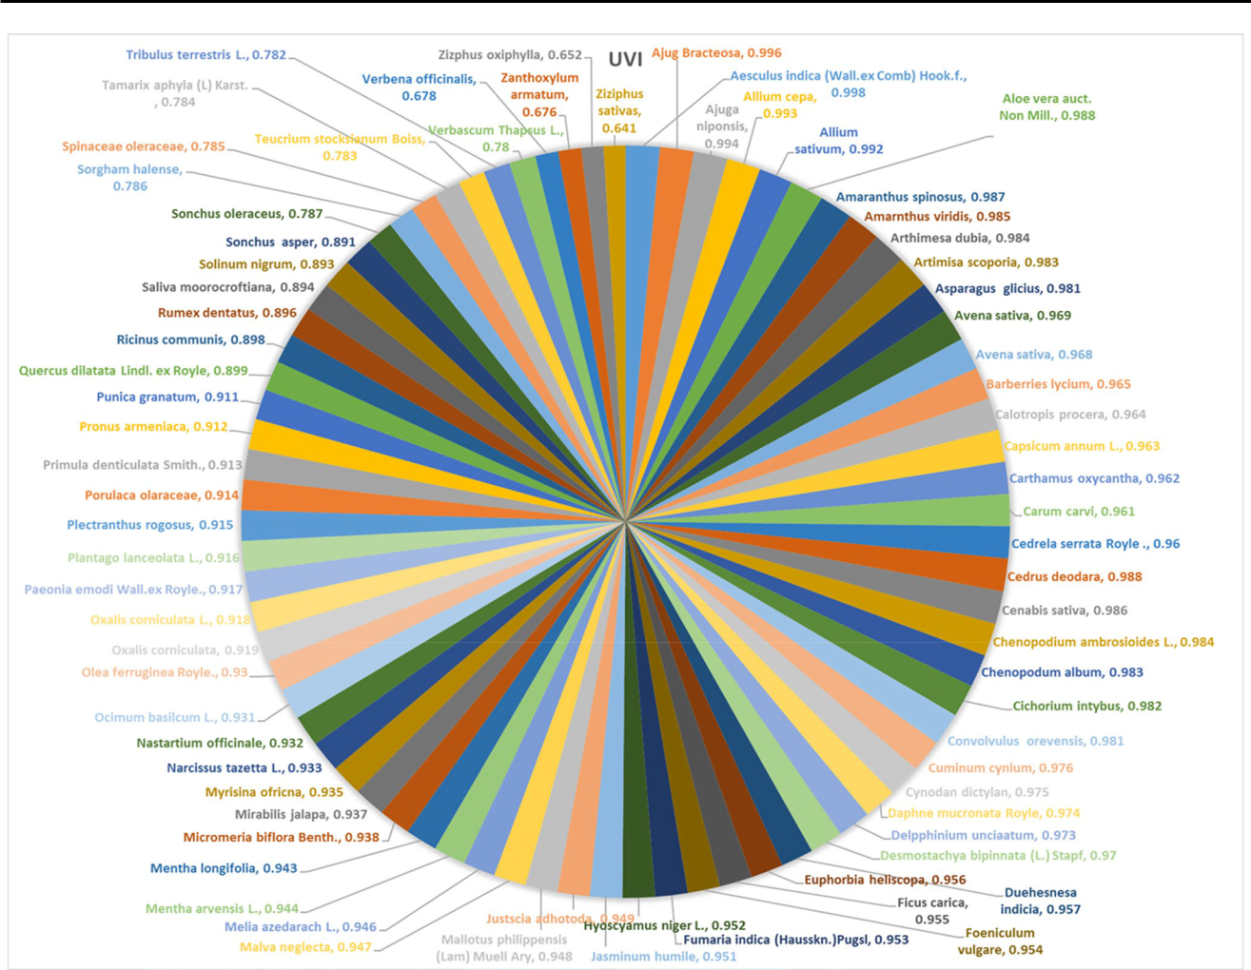

**.**

*cepaAllium sativumAloe vera*

*Amaranthus spinosusAmarnthus*

*viridisArthimesa dubiaArtimisa sco-*

*poriaAsparagus gliciusAvena sativa*

**CCI** *Barberris lyciumCalotropis procera*

*Capsicum annumCarthamus oxy* *-*

*canthaCarum carviCedrela serrata*

*Cedrus deodaraCenabis sativa*

*Chenopodium ambrosioidesCheno-*

*podum albumCichorium intybusConvol-*

*vulus orevensis* *Cuminum cyniumCyn-*

*Aesculus indica* *odan dictylanDaphne mucronata*

*Ajuga bracteosa* *Delpphinium unciaatumDesmostachya bipinnata*

*Aesculus indica* *Duehesnesa indiciaEuphor* *-*

*bia heliscopaFicus caricaFoenicu-*

*lum vulgareFumaria indica*

*Hyoscyamus nigerJasminum humile*

*Ajuga bracteosaAjuga* *Justscia adhotodaMallotus philippensis*

*bracteosaAjuga niponsisAllium* *Malva neglectaMelia*

1 3

\ N. Muhammad et al.

*Aesculus indica*

*Ajuga bracteosa*

*Ajuga niponsis*

*Allium cepa*

*Allium sativum*

*Aloe vera*

*Amaranthus spinosus*

*Amarnthus viridis*

*Arthimesa dubia*

*Artimisa scoporia*

*Asparagus glicius*

*Avena sativa*

*Barberries lycium*

*Calotropis procera*

*Capsicum annum*

*Carthamus oxycantha*

*Carum carvi*

*Cedrela serrata*

*Cedrus deodara*

*Cenabis sativa*

*Chenopodium ambro-*

*sioides*

*Chenopodum album*

*Cichorium intybus*

*Convolvulus orevensis*

*Cuminum cynium*

*Cynodan dictylan*

*Daphne mucronata*

*Delpphinium*

*unciaatum*

*Desmostachya bipin-*

*nata*

*Duehesnesa indicia*

*Euphorbia heliscopa*

*Ficus carica*

*Foeniculum vulgare*

*Fumaria indica*

*Hyoscyamus niger*

*Jasminum humile*

*Justscia adhotoda*

*Mallotus philippensis*

*Malva neglecta*

*Melia azedarach*

*Mentha arvensis*

*Mentha longifolia*

1 3

T,…

*Micromeria biflora*

*Mirabilis jalapa*

*Myrisina ofricna*

*Narcissus tazetta*

*Nastartium ofcinale*

*Ocimum basilcum*

*Olea ferruginea*

*Oxalis corniculata*

*Paeonia emodi*

*Plantago lanceolata*

*Plectranthus rogosus*

*Porulaca olaraceae*

*Primula denticulata*

*Pronus armeniaca*

*Punica granatum*

*Quercus dilatata*

*Ricinus communis*

*Rumex dentatus*

*Saliva moorocroftiana*

*Solinum nigeum*

*Sonchus asper*

*Sonchus oleraceus*

*Sorgham halense*

*Spinaceae oleraceae*

*Tamarix aphyla*

*Teucrium stocksianum*

*Tribulus terrestris*

*Verbascum Thapsus*

*Verbena ofcinalis*

*Zanthoxylum armatum*

*Ziziphus oxiphylla*

*Ziziphus sativa*

*azedarachMentha arvensisMentha*

*longifoliaMicromeria biflora*

*Aesculus indica*

**I**

1 3

\ N. Muhammad et al.

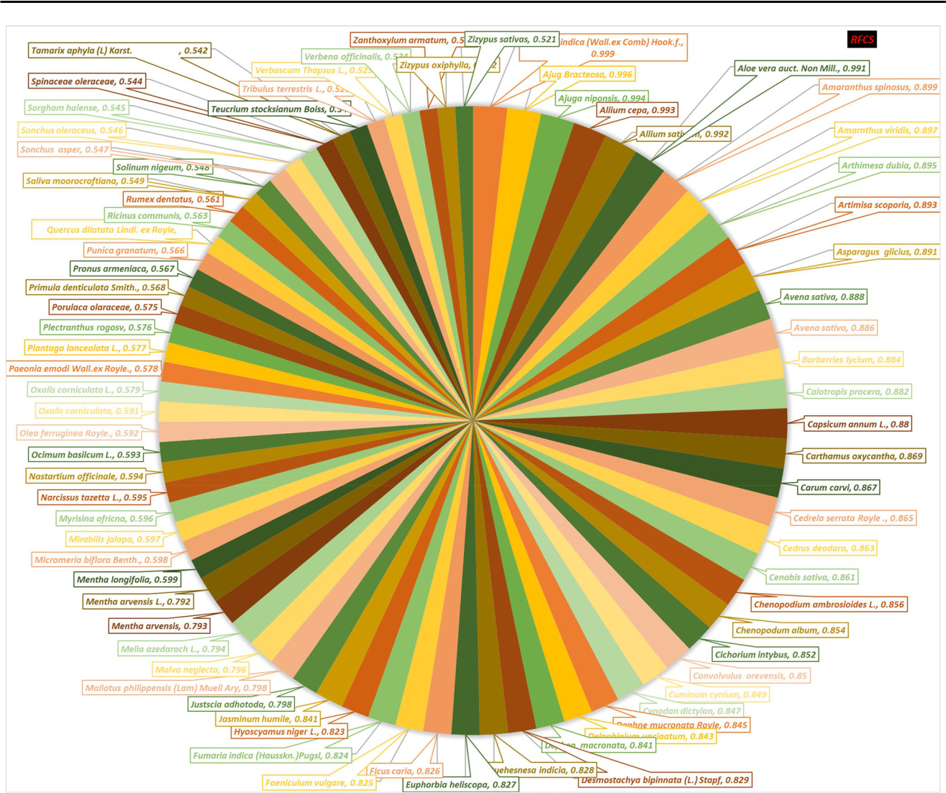

**.**

f

1 3

T,…

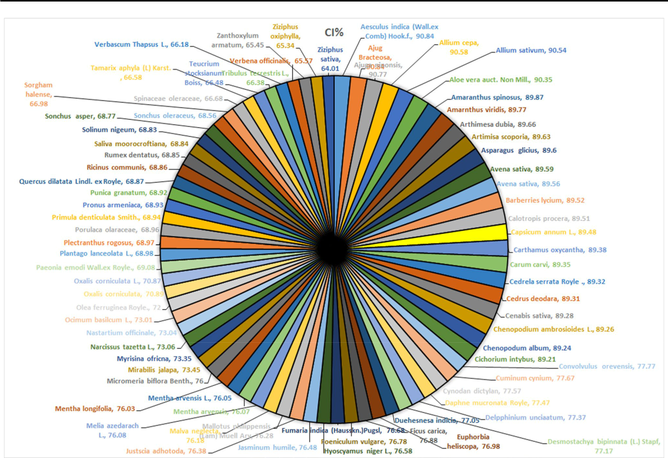

**.**

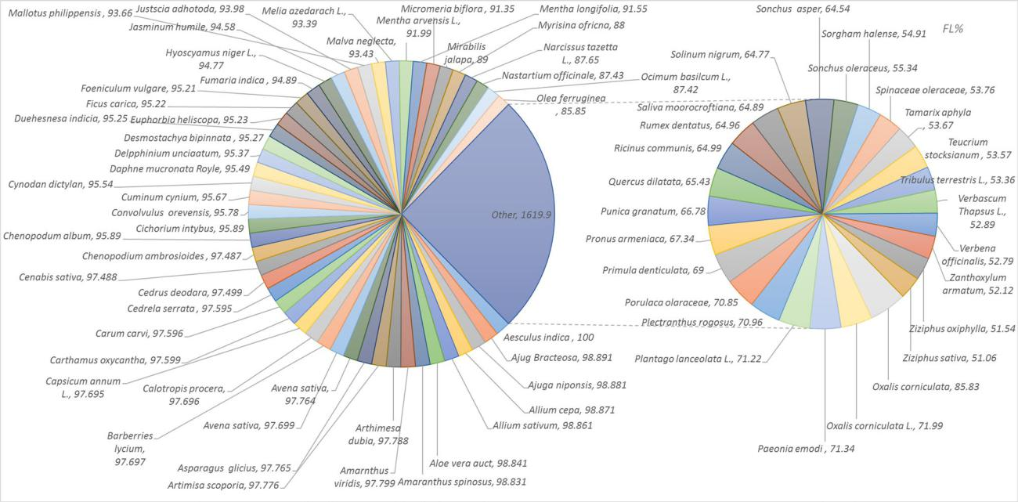

**.**

1 3

\ N. Muhammad et al.

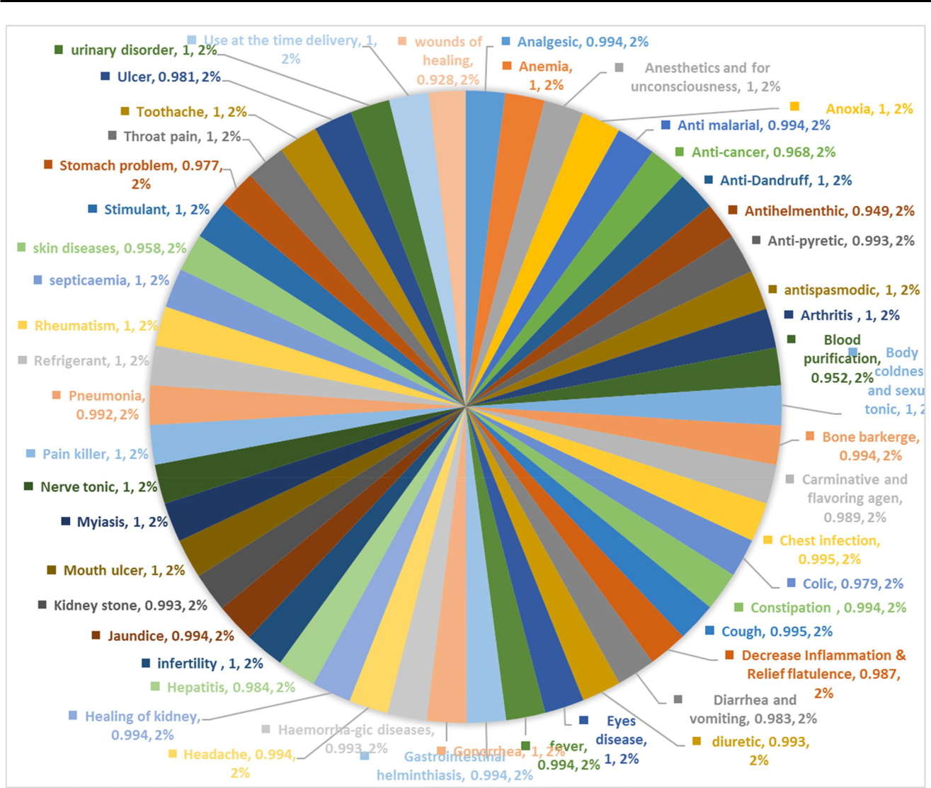

|  |  |  |  |
| --- | --- | --- | --- |
| **.** | ’ |  |  |
|  |  | *Aesculus* |  |
|  |  | *indicaAjuga bracteosa* |  |
| **Conclusion** | | *Aesculus indica* |  |
| *Ajuga bracteosa* |  |

*Ajuga niponsisAllium cepa*

*Aesculus indicaAjuga*

*bracteosa.Aesculus indica*

*Ajuga brac-*

*teosa*

1 3

T,…

f

*Ajuga bracteosa*

*Aesculus indica*

**A**

**A’**

**A**

**Compliance with ethical standards**

**C**

1 3

\ N. Muhammad et al.

**References**

*Trachyspermum ammi*

*Ipomoea*

*Punica*

*Ziziphus*

*Thymus vulgaris*

*Helicobacter pylori*

*Ficus carica*

*Anethum graveoleusMentha*

*piperitaPinus sylvestris*

*Drosophila melanogaster*

1 3

T,…

**P’**

1 3